|  |
| --- |
| COACHING INSTITUTE ANALYSIS |

|  |
| --- |
|  |

**Abstract:**

* In the “Coaching Institute Analysis”, we can store data in database which were stored manually before which required man power and place to store the records.
* Due to manual maintenance lots of faults are occurred so it is needed to replace existing system by automated web system.
* Web system is time saving and gives better performance than existing manual system.
* It is a product log on to various activities and to provide instantaneous information required in a proper way for an effective management of that institute.

**Introduction:**

* The project consists of two modules: 1. Admin module and 2. Student module.
* The students can register themselves and create a unique ID and password of their own and save their information.
* The admin can view all the saved information of the students admitted in the coaching classes with admin’s own unique ID and password.
* The students will be giving tests of subjects M1 and Graphics and the marks obtained will be stored and graphs will be displayed for analysis.
* Student reports and marks will be mailed to the students directly through SMTP protocol.

**Problem Statement:**

* An Engineering Class Owner/Tutor wants an application for the analysis of his students by the tests conducted.
* The subjects taught are Mathematics-1 and Engineering Graphics.
* The reports of each student according to subjects are to be made available to him.
* According to the reports, data analysis should be made for better understanding of students' performances.
* For this purpose, data analysis techniques are to be applied using python.
* Also, direct results in the form of mails are to be sent.

**Objectives:**

* To maintain all the accounts of the students in digital form from enrollment up to the end of the study.
* To make information accessible to the Admins at the desk in just a click away.
* To have centralized control of records to the students and monitor changes in the records.
* To ease the process of understanding students' performances with the help of data analysis technique.
* Send results of the students in the form of Emails.

**Outcomes:**

* The owner will be able to handle the course wise data of the students.
* Automated Email system will be made available to the owner for direct and formal contact with the students/parents.
* Simple and accurate results in the form of Graph will be displayed for ease in analysis of student performance.
* Ease in planning for teaching of each students according to reports.
* Personalized attention according to strengths and weaknesses of students.

**S/W and H/W required:**

* + Python Django
  + Atom text editor
  + Sublime text editor
  + A Computer System
  + Internet Connection
  + Data provided by Sponsor
  + Disk space: 2 to 3 GB or more
  + Processors: Intel Atom® processor or Intel® Core™ i3 processor or later versions.

**Keywords:**

* Centralized Control
* Easy Maintenance
* Admin module
* Student module
* Email module

**Functional requirements:**

* Proper Verification and Validation that:
  + 1. No invalid entries are there
    2. No duplication is present
    3. No missing values in the database
    4. Mail ID verification
* Admin should be able to register himself and enter test marks.
* Students should be able to register and enter their information.
* Admin should view the students’ database/information.
* Graphs should be visible to the students as well as the Admin.
* Admin should be able to send Emails.

**Non functional requirements:**

* Usability - User-friendliness and proper Graphical User Interface for both Students and Admin.
* Supportability - It should support all types of systems and operating systems as per Admin requirements.
* Performance - Efficient and accurate performance regarding security, analysis according to the graphs and SMTP protocol.
* Reliability - Reliable project for database storage and accurate graphs
* Maintainability - Low maintenance costs and negligible errors.
* Serviceability - Easy and punctual post deployment services in case of failures.

**Design/Block Diagram:**

can

can

Database

View and Delete

Create

can

can

Create and Enter

Display and View

Send Mails

Receive Mails

**Use Case Diagram:**

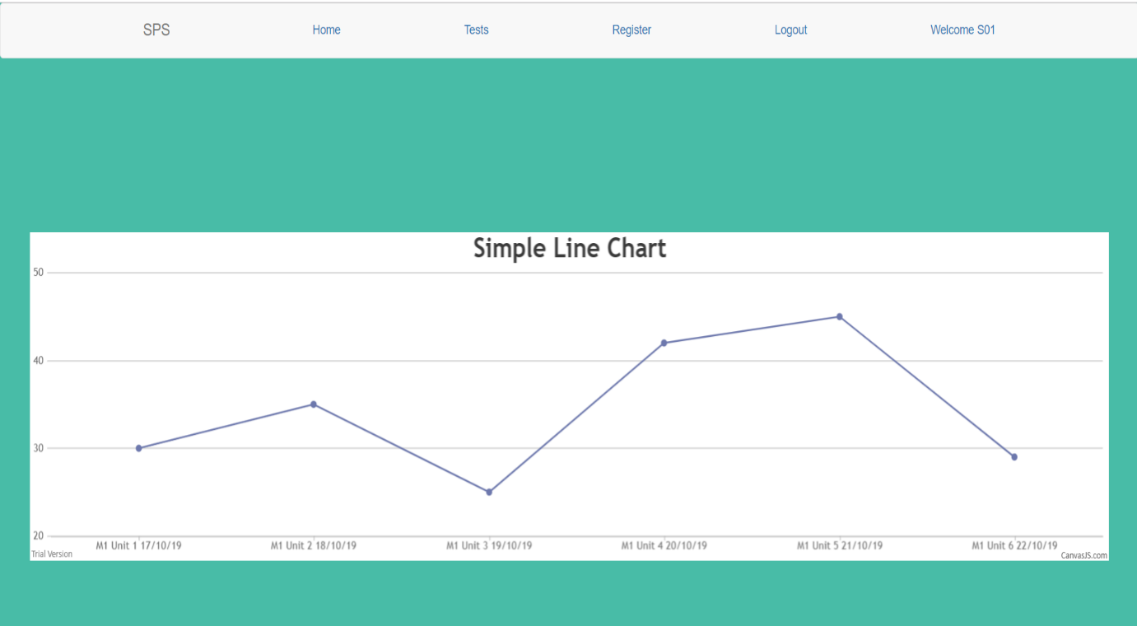

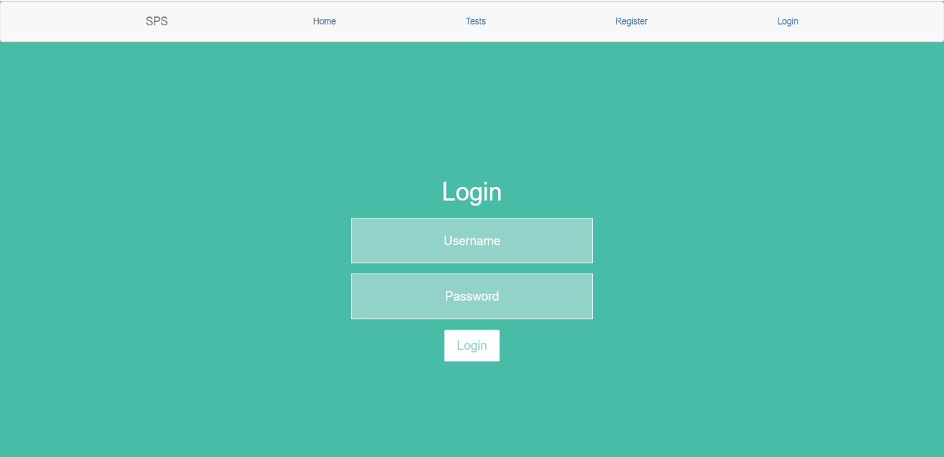

**Use Case Diagram:**

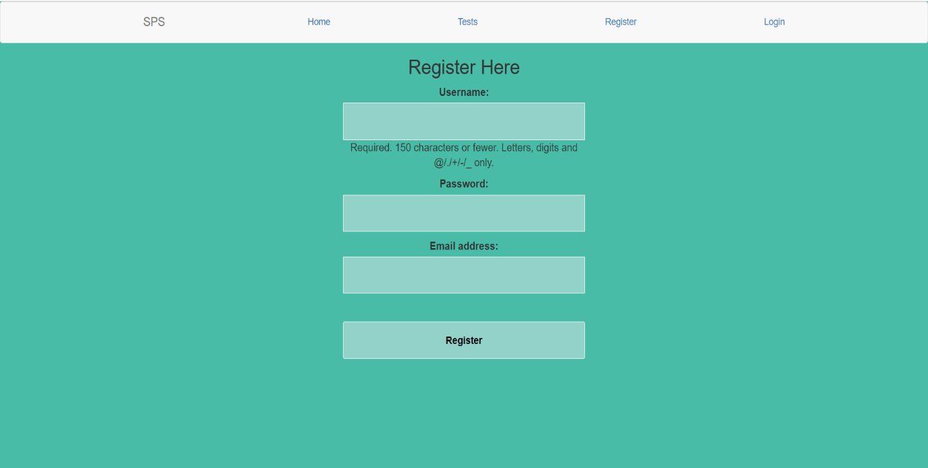

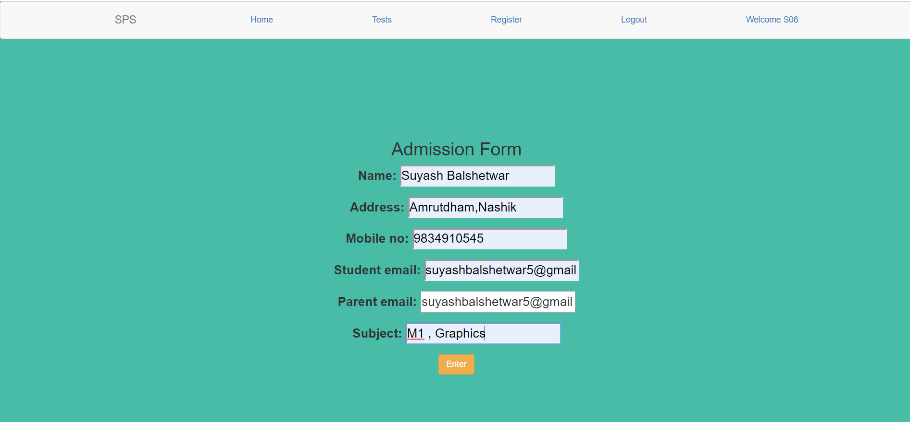

**Database:**

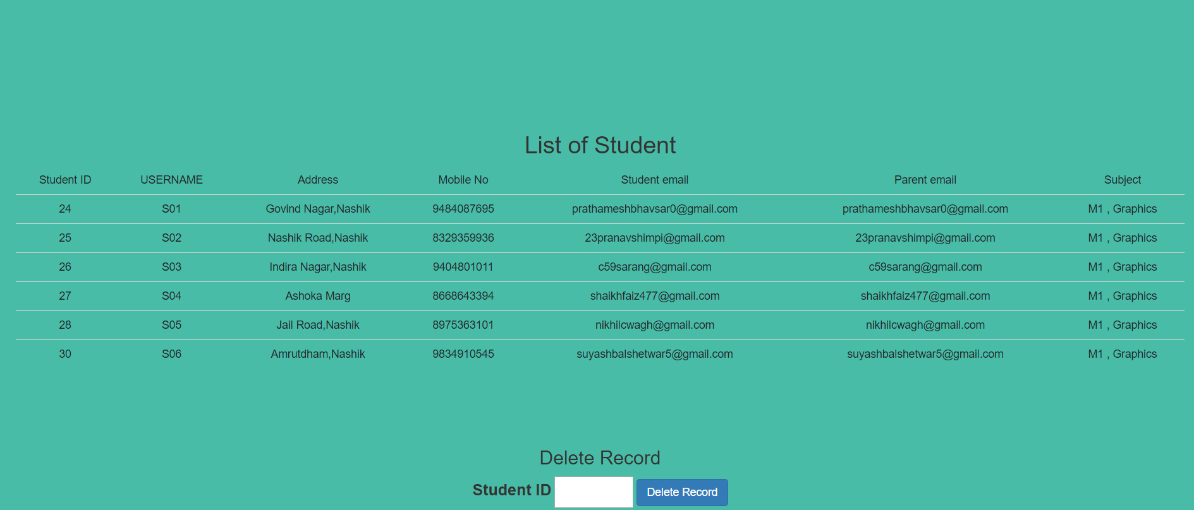

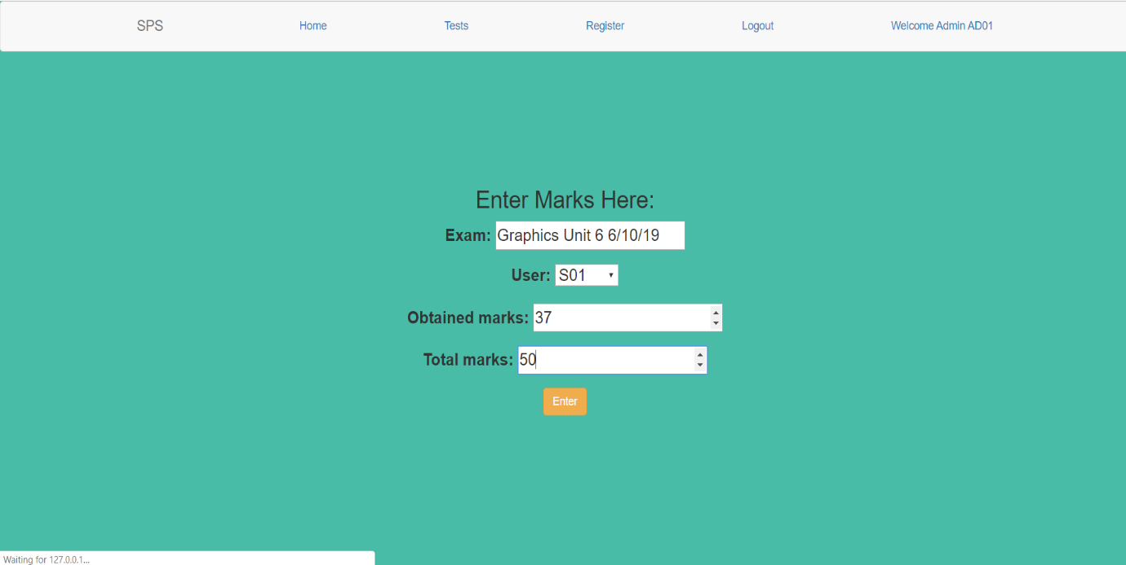

**Test cases:**

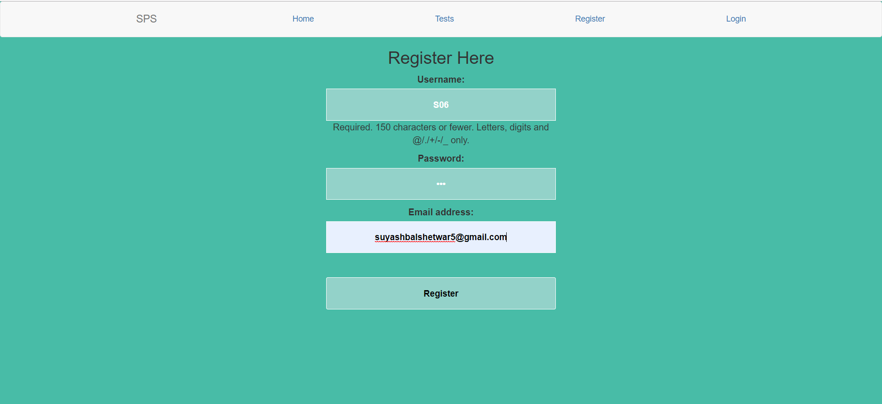

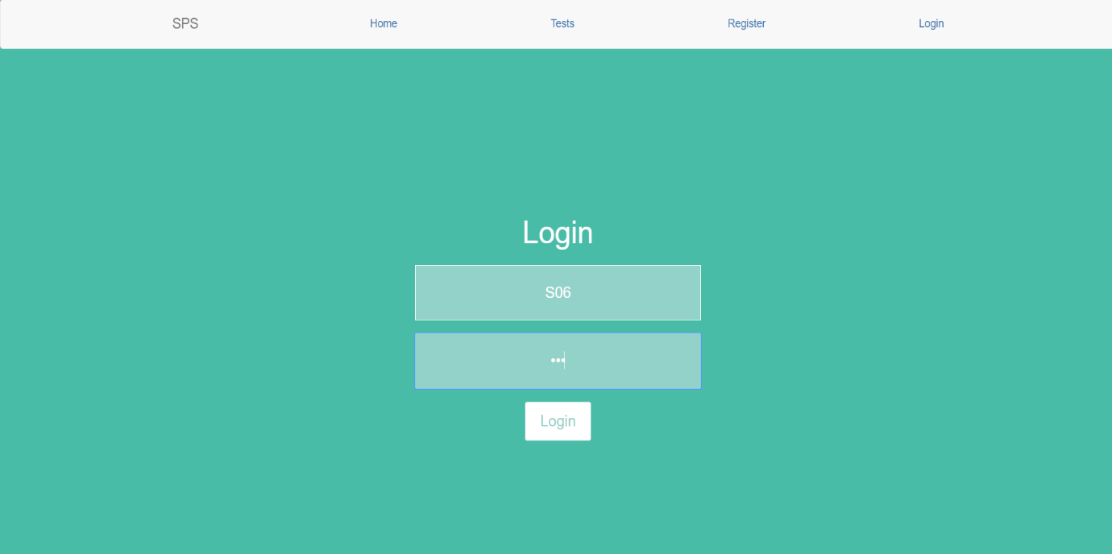

**Test Cases:**

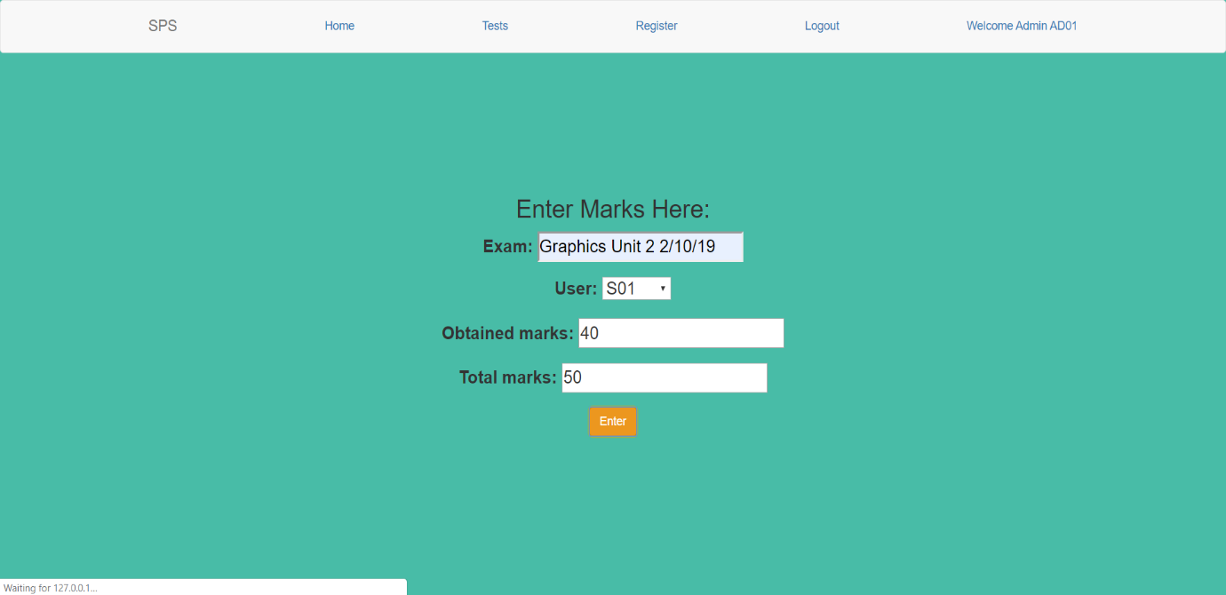

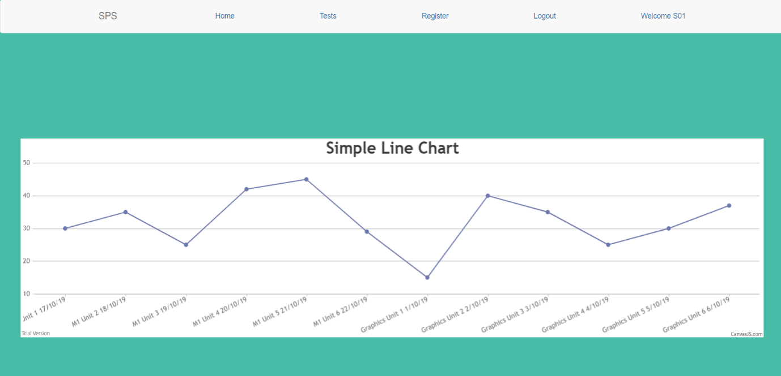

**Results/Observations:**

* Easy to maintain the student database.
* It will reduce the manual work.
* Graph of students’ marks in tests conducted.
* Easy analysis of students’ progress.
* Easy to find individual student database and also delete the records.
* Admin can send email the students’ marks to the students directly.

**Conclusion:**

* “Coaching Institute Analysis” project developed for an institute has been designed to achieve efficiency and reduce the time taken to handle the activities.
* It is designed to replace the existing manual record system thereby reducing the time taken for calculations and for storing data and its analysis.
* The implementation of the system in an organization will considerably reduce the data entry, time and also provide readily calculated and analyzed reports.

**References:**

* Django Documentation: https://docs.djangoproject.com/en/2.2/
* Django Reference video: https://www.youtube.com/watch?v=Z4D3MNSN58&list=PLzMcBGfZo4-kQkZp-j9PNyKq7Yw5VYjq9
* Django Book: <https://djangobook.com/>
* Udemy Full Stack Web Development Course by Jose Portilla which :
* 1.HTML
* 2.CSS
* 3.Bootstrap
* 4.jQuery
* 5.JavaScript
* 6.Django

**Future Scope:**

* The system is interactable and flexible and changes can be made further to increase the efficiency of the Admin.
* More updates can be made on the project such as Parent Login, Attendance management, Fees management, Examination Module, Subject module.
* This project sample will be helpful to other Coaching Classes as well if modified further or upgraded according to their needs.
* Time to time upgradation and post-deployment services will lead to the benefit of both user and developer.